Music Theory

MUSIC.

**Introduction 2**

**Fundamentals of Music Theory 2**

Notes 2

Intervals 3

**Scales & Keys 3**

Introduction 3

Major Scale 4

Minor Scale 4

Degrees of a Scale 4

Scale Degrees Function 5

Diatonic Chords 6

Modal Scales 6

**Chords and Harmony 7**

Chords 7

Basic Triads 7

Suspended Chords 8

Seventh Chords 8

Extended Chords 8

Added Chords 9

Chord Inversion 9

**Chord Progressions 10**

Popular Chord Progressions 10

Cadence 11

**Advanced Harmony Techniques 11**

Passing Chords 11

Chord Borrowing 12

Voice Leading 12

Passing Tones 12

Suspension 12

**Modulation & Key Changes 13**

Circle of Fifth 14

Finding Diatonic Chords 15

Finding Borrowed Chords 15

Using the Circle for Modulation 15

**Rhythm & Timing 16**

Time Signature 16

On-Beat VS. Off-Beat 16

Triplet 16

Syncopation 17

Swing 17

**Song Structure 18**

Sections of a Song 18

# Introduction

This is a quick introduction to music theory, it could serve as a quick reference.

# Fundamentals of Music Theory

## Notes

A distance between each note is called a **semitone** and it is the smallest unit of change in pitch, for example between C → C# and E → F.

Here is a quick reference photo of different notes.

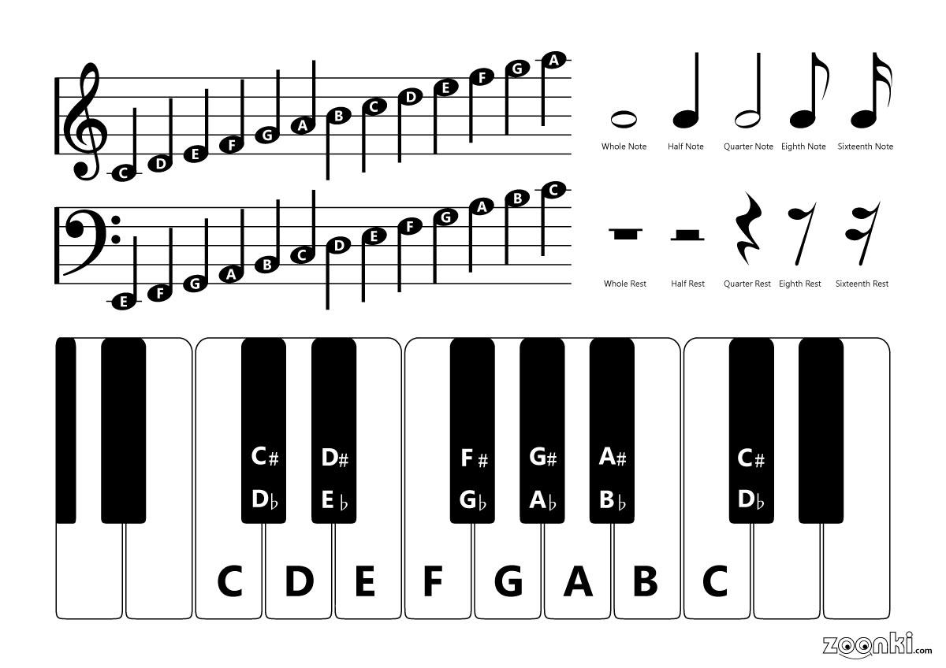

## Intervals

In music theory, an interval is a difference in pitch or a distance between two sounds.

| **Name** | **Abbreviation** | **Smitones** |
| --- | --- | --- |
| **Perfect Intervals** | | |
| Perfect Unison | P1 | 0 |
| Perfect 4th | P4 | 5 |
| Perfect 5th | P5 | 7 |
| Perfect Octave | P8 | 12 |
| **Major and Minor Intervals** | | |
| Minor 2nd Half Step | m2 | 1 |
| Major 2nd Whole Step | M2 | 2 |
| Minor 3rd | m3 | 3 |
| Major 3rd | M3 | 4 |
| Minor 6th/Augmented 5th | m6 | 8 |
| Major 6th | M6 | 9 |
| Minor 7th | m7 | 10 |
| Major 7th | M7 | 11 |
| **Augmented and Diminished Intervals** | | |
| Tritone/Diminished 5th | TT | 6 |

# Scales & Keys

## Introduction

A scale is a series of notes arranged in ascending or descending order of pitch. These notes are typically drawn from a specific set of intervals and are organized within an octave.

Some common scales are Major scales and its 7 modes (Ionian, Dorian, Phrygian, Lydian, Mixolydian, Aeolian Natural Minor, and Locrian), Melodic Minor, Harmonic Minor, Pentatonic scales, and Blues scale.

A Key in the other hand is the application of a given scale “formula” starting from a tonal center for instance C Major, C is the tonal and Major is the “formula”, below are the formulas of the Major and Minor scales.

## Major Scale

The major scale is a seven-note scale that is known for its bright, happy, or uplifting sound. It could be constructed using the following formula:

**Whole - Whole - Half - Whole - Whole - Whole - Half**

## Minor Scale

The minor scale is a seven-note scale that is known for melancholic and introspective sound. It could be constructed using the following formula:

**Whole - Half - Whole - Whole - Half - Whole - Whole**

## Degrees of a Scale

The scale degree is the position of a particular note on a scale relative to the tonic (first note),

The different degrees are:

| **Degree** | **Name** |
| --- | --- |
| 1 | Tonic |
| 2 | Supertonic |
| 3 | Mediant |
| 4 | Subdominant |
| 5 | Dominant |
| 6 | Submediant |
| 7 | Subtonic |

Here is an example of degrees in a C Major key



The tonic note is the **centre**, Then the supertonic and subtonic are, respectively, a 2nd above and below the tonic; the mediant and submediant are a 3rd above and below it; and the dominant and subdominant are a 5th above and below the tonic.

Here a visual representation

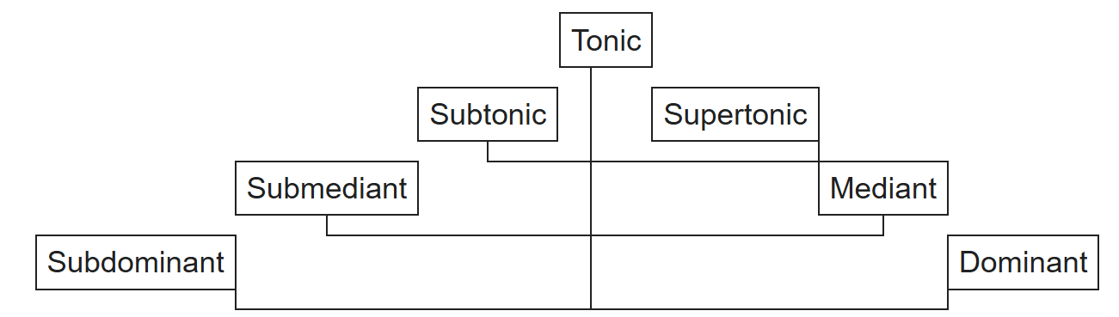

### Scale Degrees Function

* **Tonic:** This is the home note of the scale, the root, and the center of gravity. It feels like the resolution point and gives a sense of completion or rest.
* **Supertonic:** This note is one step above the tonic. It typically functions as a passing or transitional note, leading towards the dominant.
* **Mediant**: The mediant provides the harmony between the tonic and dominant. It defines whether the scale is major or minor and has a harmonic role in shaping the chord structure.
* **Subdominant:** Located just below the dominant, this degree has a tension that needs resolution, often moving to the dominant or back to the tonic.
* **Dominant:** This degree is a crucial tension point. It creates a sense of anticipation and is usually resolved back to the tonic.
* **Submediant:** This is one step below the tonic, and it is often seen as a relative minor or major key. It provides a softer resolution when moving away from the dominant.
* **Subtonic:** This note is one step below the tonic, and it creates a sense of tension. In natural minor scales, the subtonic functions as a leading tone to the tonic

#### 

### Diatonic Chords

In every scale or mode, each scale degree corresponds to a specific chord quality (such as Major, Minor, Diminished, etc.).

To determine the chord for each degree (which are called diatonic chords), start by playing the root note, then skip one scale note to find the 3rd, and skip another to find the 5th, forming a triad. The quality of each triad depends on the structure of the scale.

Below are lists of the chord qualities for both Major and Minor scales.

| **Scale Degree** | **Chord Quality** |
| --- | --- |
| **Major** | |
| I | Major |
| ii | Minor |
| iii | Minor |
| IV | Major |
| V | Major |
| vi | Minor |
| vii° | Diminished |
| **Minor** | |
| i | Minor |
| ii° | Diminished |
| III | Major |
| iv | Minor |
| v | Minor |
| VI | Major |
| VII | Major |

## Modal Scales

In music theory, modes refer to different types of scales that are derived from the diatonic scale (the natural major scale) but start on different notes, for instance playing all the white notes from C Major “Aeolian” but starting from D you get D Dorian.

Each mode has its own unique sound and character based on the arrangement of whole steps and half steps.

| **Mode** | **Formula** | **Character** |
| --- | --- | --- |
| Ionian Major Scale | W-W-H-W-W-W-H | Bright and happy. |
| Dorian | W-H-W-W-W-H-W | Minor scale with a jazzy or bluesy feel, often described as a dark but hopeful sound. |
| Phrygian | H-W-W-W-H-W-W | Exotic, Spanish, or Middle Eastern feel, often seen as a dark mode. |
| Lydian | W-W-W-H-W-W-H | Bright and dreamy, like a major scale with a raised 4th. |
| Mixolydian | W-W-H-W-H-W-W | Similar to a major scale, but with a bluesy or rock feel due to the lowered 7th degree. |
| Aeolian Natural Minor | W-H-W-W-H-W-W | A sadder or darker sound |

# Chords and Harmony

## Chords

### Basic Triads

| **Name** | **Formula** | **Description** |
| --- | --- | --- |
| Major (Maj) | Root + Major 3rd + Perfect 5th | One of the most essential chords, it is the first building block for the other chords.  Bright, stable, happy sound. |
| Minor (Min) | Root + Minor 3rd + Perfect 5th | Darker, sadder than major. |
| Diminished (Dim) | Root - Minor 3rd - Diminished 5th | Tense, unstable, often resolves to major/minor. |
| Augmented (Aug) | Root - Major 3rd - Augmented 5th | Dreamy, mysterious, lacks resolution. |

### 

### Suspended Chords

| **Name** | **Formula** | **Description** |
| --- | --- | --- |
| Suspended 2 (Sus2) | Root - Major 2nd - Perfect 5th | Open, floating sound, resolves to major/minor. |
| Suspended 4 (Sus4) | Root - Perfect 4th - Perfect 5th | Tension-filled, resolves to major/minor |

### Seventh Chords

| **Name** | **Formula** | **Description** |
| --- | --- | --- |
| Dominant 7 (7) | Root - Major 3rd - Perfect 5th - Minor 7th | Bluesy, used in V-I resolutions. |
| Major 7 (Maj7) | Root - Major 3rd - Perfect 5th - Major 7th | Smooth, jazzy, dreamy. |
| Minor 7 (Min7) | Root - Minor 3rd - Perfect 5th - Minor 7th | Softer than minor, used in jazz/R&B. |
| Half-Diminished (Min7♭5) | Root - Minor 3rd - Dim 5th - Minor 7th | Tense but not as harsh as dim7. |
| Diminished 7 (Dim7) | Root - Minor 3rd - Diminished 5th - Dim 7th | Very unstable. |

### Extended Chords

| **Name** | **Formula** | **Description** |
| --- | --- | --- |
| Dominant 9 (9) | Root - Major 3rd - Perfect 5th - Minor 7th - Major 9th | Rich, jazzy dominant chord. |
| Major 9 (Maj9) | Root - Major 3rd - Perfect 5th - Major 7th - Major 9th | Lush, used in jazz and R&B. |
| Minor 9 (Min9) | Root - Minor 3rd - Perfect 5th - Minor 7th - Major 9th | Dreamy, emotional. |
| Dominant 11 (11) | Root - Major 3rd - Perfect 5th - Minor 7th - Major 9th - Perfect 11th | Ethereal, often used in modern jazz. |
| Major 11 (Maj11) | Root - Major 3rd - Perfect 5th - Major 7th - Major 9th - Perfect 11th | Soft, floating sound. |
| Minor 11 (Min11) | Root - Minor 3rd - Perfect 5th - Minor 7th - Major 9th - Perfect 11th | Darker, ambient feel. |
| Dominant 13 (13) | Root - Major 3rd - Perfect 5th - Minor 7th - Major 9th - Perfect 11th - Major 13th | Very rich, used in jazz/funk. |
| Major 13 (Maj13) | Root - Major 3rd - Perfect 5th - Major 7th - Major 9th - Perfect 11th - Major 13th | Full, orchestral sound. |
| Minor 13 (Min13) | Root - Minor 3rd - Perfect 5th - Minor 7th - Major 9th - Perfect 11th - Major 13th | Dark but warm. |

### Added Chords

| **Name** | **Formula** | **Description** |
| --- | --- | --- |
| Add9 (Add9) | Root - Major 3rd - Perfect 5th - Major 9th | Bright, open sound. |
| Minor Add9 (MinAdd9) | Root - Minor 3rd - Perfect 5th - Major 9th | Sad but spacious. |
| 6th Chord (6) | Root - Major 3rd - Perfect 5th - Major 6th | Vintage, used in jazz and R&B. |
| Minor 6 (Min6) | Root - Min3rd - 5th - Maj6th | Mysterious |

These chords, as shown in the tables, are variations of the basic triads and can be used as substitutions for the diatonic chords in a chord progression.

## 

## Chord Inversion

Chord inversion refers to the rearrangement of the notes in a chord, such that a note other than the root note is played as the lowest note.

When a chord is in its root position, the lowest note is the root of the chord. An inversion occurs when one or more notes in the chord are shifted so that a different note becomes the lowest note.

* **Root position:** The root note is the lowest note. C major chord (C - E - G), the C is the bass note.
* **First inversion:** The third of the chord becomes the lowest note. C major chord (E - G - C).
* **Second inversion:** The fifth of the chord becomes the lowest note. C major chord (G - C - E.).
* **3rd, 4th, 5th Inversion (for 7th chords and beyond)**: Higher extensions (7th, 9th, 11th, or 13th) can be placed in the bass.

Inversions can add variety to the harmony, create smoother voice leading (the way individual notes move between chords), and provide different sounds or emotions within a progression.

# Chord Progressions

A chord progression is a sequence of chords played in a particular order, where the chords are typically built from the scale degrees of the key. These chords are often referred to by their scale degree names, such as I, II, V, etc.

## Popular Chord Progressions

| **Chord Progression** | **Scale** | **Example** |
| --- | --- | --- |
| I - V - vi - IV | Major | Lena Del Rey - Love |
| vi - IV - I - V | Major | Alan Walker’s - The Spectre |
| I-vi - IV - V | Major | Taylor Swift’s - ME! |
| IV - V - I - vi | Major | Chappell Roan - Good Luck, Babe! |
| ii - V - I | Major | Maroon 5 - Sunday Morning |
| i - VII - VI - V | Minor | Dire Straits - Sultans of Swing |
| I - IV - V | Major | Charli XCX - detonate |
| I - VII - VI - VII | Minor | Adele - Rolling In The Deep |

## Cadence

cadence refers to a sequence of chords that brings a phrase, section, or piece of music to a close or a resting point. It’s like a musical punctuation mark that signals the end of a musical thought. Cadences help to establish the harmonic rhythm and overall structure of the music.

Below is table of the most common cadences

| **Name** | **Feel** | **Sequence (Chords or Notes)** |
| --- | --- | --- |
| Authentic Cadence (Perfect or Imperfect) | Resolute and final | 5 → 1 |
| Half Cadence | Unfinished or suspended | (1, 2, 4, 6) → 5 |
| Plagal Cadence | Soft, church-like, or peaceful | 4 → 1 |
| Deceptive Cadence | Surprising or unexpected | 5 → 6 |

# Advanced Harmony Techniques

## Passing Chords

A passing chord in music theory is a chord inserted between two diatonic chords to create smoother or more interesting harmonic movement.

Below are the most common forms of passing chords

| **Type** | **Description** |
| --- | --- |
| Diatonic Passing Chord | Add a diatonic chord between two existing chord in a chord progression |
| Chromatic Passing Chord | Chromatically move (Raise the root note of the first chord by a semitone) to the next chord in a chord progression |
| Secondary Dominant | Play the Dominant (5) chord of the next chord |
| Diminished Passing Chords | A rare technique used in Jazz |
| Augmented Passing Chords | A rare technique used in Jazz |

## Chord Borrowing

Chord borrowing (also called modal mixture) is when a chord is taken from a parallel key (major or minor) and used in a progression. This adds color, variety, and emotional contrast while staying connected to the original key.

A Parallel Key is the key with the same tonic but in the parallel mode, the parallel mode of C Major is C Minor.

## Voice Leading

Voice leading refers to the way individual melodic lines move from one chord to another in a smooth and coherent manner. Good voice leading minimizes large leaps and awkward motion between notes, creating a more natural and pleasing sound. Some key principles include:

* Stepwise motion (moving by half or whole steps) is preferred over leaps.
* Avoiding parallel fifths and octaves, which can make the texture sound hollow.
* Keeping common tones when possible to create smooth transitions.

## Passing Tones

A passing tone is a note that does not belong to the underlying chord that occurs between two chord tones, creating a smooth stepwise connection. It usually happens on a weak beat and resolves by step.

## Suspension

A suspension is when a note from a previous chord is held over into the next chord, creating temporary dissonance before resolving.

# 

# Modulation & Key Changes

Modulation is the change from one tonality (tonic, or tonal center) to another. This is mainly done with a change from a key to another for instance from C Major to A Minor.

Below are the most common ways to achieve modulation:

| **Name** | **Description** |
| --- | --- |
| Direct Modulation | This happens without any preparation or transition. The music just jumps from one key to another. |
| Chromatic Modulation | This means that one or more chords in the original key are altered by moving them a half step up or down, which creates a smooth transition to a new key. |
| Parallel Key Modulation | The shift happens from a major key to its parallel minor key (or vice versa) while keeping the same tonic note, C Major → C Minor |
| Relative Key Modulation | The shift happens from a major key to its relative minor key (or vice versa). Relative keys are Major and Minor keys that share the same notes but in different order, C Major → A Minor |
| Common Chord Modulation | The shift happens by using a chord that is shared by both the original key and the new key. |
| Dominant Modulation | The shift happens by using the dominant (V) of the target key as a pivot chord and then resolve to the root of the target key (I) |

## 

## Circle of Fifth

The Circle of 5ths is a visual representation of the 12 tones in Western music, arranged in a way that helps musicians understand key signatures, chord progressions, and relationships between notes.

Moving clockwise, each note is a perfect 5th above the previous one.

Moving counterclockwise, each note is a perfect 4th above the previous one.

Relative minor keys are placed inside the circle, directly below their major counterparts.

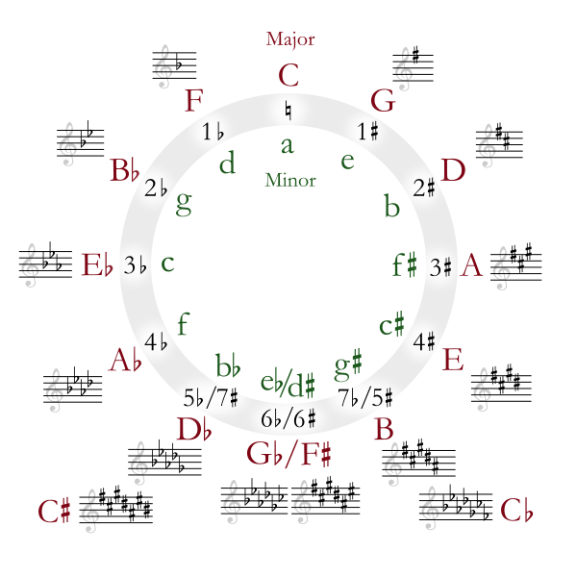

### Finding Diatonic Chords

Let’s say we are in the key of C Major. If you take all the adjacent chords and their notes from the Circle of 5ths (C, F, G, Am, Dm, Em), you will end up with all the diatonic chords of the C Major key. These chords can be easily mixed together to create a chord progression.

### Finding Borrowed Chords

Borrowed chords refer to the technique of incorporating chords from another key into a chord progression of the key you're currently playing, typically from the parallel key.

To find which borrowed chords work well with the key you're in, look for the parallel key on the Circle of 5ths. The parallel key shares the same tonic note but can be either major or minor.

For example, if you’re in C Major, its parallel key would be C minor. The chords you can borrow are the diatonic chords from C minor (c, f, g, Ab, Bb, Eb); these chords are in the group of 6 that are adjacent to C minor in the circle.

### Using the Circle for Modulation

Modulation is the technique of switching from a key to another.

We can use the circle of 5th to do that some common techniques are as follow:

* Clockwise/Counterclockwise modulation (by 5ths): Moving to neighboring keys (C to G).
* Dominant modulation: Using the V chord of the target key (C to E to A).
* Relative major/minor modulation: Modulating between a major key and its relative minor (C to a).

# 

# Rhythm & Timing

## Time Signature

A time signature in music theory is a notation that indicates how many beats are in each measure (or bar) of music and what note value gets one beat. A time signature is written as two numbers, one on top of the other, placed at the beginning of a piece of music.

* **Top number:** This tells you how many beats there are in each measure. For example, a "4" on the top means there are 4 beats in each measure.
* **Bottom number:** This tells you what type of note gets one beat.

For example:

* **4/4:** Four beats per measure, and the quarter note gets one beat. This is the most common time signature, often called "common time."
* **3/4:** Three beats per measure, with the quarter note getting one beat (often used in waltzes).
* **6/8:** Six beats per measure, with the eighth note getting one beat (often used in compound time signatures).

## On-Beat VS. Off-Beat

On-beat and Off-beat are terms used to describe the placement of notes or rhythms in relation to the main beats in a measure.

In a 4/4 time signature, playing a note on beats 1, 2, 3, or 4 is considered on-beat, with beat 1 being the strongest beat, followed by beat 3, and then beats 2 and 4, which are weaker but still considered on-beat.

Notes that fall between the main beats (1, 2, 3, or 4) are considered off-beat.

To identify off-beats, you can subdivide the beats by counting "1-e-&-a-2-e-&-a-3-e-&-a-4-e-&-a". In this subdivision, the "e," "&," and "a" are considered off-beats.

## Triplet

A triplet in music theory refers to a rhythmic pattern where three notes are played in the time typically allocated for two notes of the same value. In other words, a triplet divides a beat into three equal parts instead of the usual two.

To count for triplets you can use the following “1-trip-let-2-trip-let-3-trip-let-4-trip-let”

## Syncopation

Syncopation is a musical technique where the expected rhythm or emphasis is shifted, often by placing accents or notes on weak beats or off-beats, creating a sense of surprise or tension. It essentially displaces the usual pattern of strong and weak beats, making the rhythm feel less predictable and more dynamic, Below are some general rules of syncopation:

* **Emphasis on Weak Beats:** Syncopation often involves accenting or playing notes on the weaker beats (2 and 4).
* **Off-Beat Notes:** Notes might be placed on the off-beats, like in the “&” or “e” subdivisions, creating a sense of rhythmic tension.
* **Breaking Predictability:** Syncopation can make a rhythm feel "off-beat" or "uneven," adding a level of unpredictability and excitement to the music. This often makes the rhythm groove more interesting and lively.

## Swing

Swing refers to a rhythmic feel or groove, it involves a particular way of playing or interpreting eighth notes, creating a lilt or bounce in the rhythm.

Rather than playing notes evenly (with each note taking the same amount of time), swing involves dividing the notes into a long-short pattern, where the first note of each pair (Downbeat) is slightly longer, and the second note (Upbeat) is slightly shorter.

# Song Structure

## Sections of a Song

| **Section** | **Description** | **Purpose** |
| --- | --- | --- |
| Intro | A short opening segment, often instrumental or with minimal lyrics, setting the tone for the song. | Establishes mood and atmosphere, catches listener's attention. |
| Verse | A storytelling section where lyrics typically change each time, providing context or progression of the song's narrative. | Develops the song’s theme or narrative, gives more details to the listener. |
| Pre-Chorus | A transitional section that builds energy or tension leading into the chorus. Often has a different melody or rhythm from the verse. | Increases anticipation and emotional intensity before the chorus. |
| Chorus | The central, repeating section with the song's main message, usually with a catchy melody and lyrics. Often the most memorable part of the song. | Delivers the main theme or hook of the song; easily recognizable and singable. |
| Bridge | A contrasting section, often with different melody, lyrics, or rhythm from the verse and chorus, offering a break in the structure. | Provides variety and adds emotional or musical contrast before returning to the chorus. |
| Outro | The closing section, which may fade out or resolve the song, sometimes echoing the intro or fading to a conclusion. | Brings the song to a satisfying or reflective end, completing the structure. |